Capital Budgeting online simulation analysis report
Financial Management
Professor Viktoria Dalko
By Xiaolin Zheng, Hult Global MBA, March 19, 2018

Overall strategy
Company and Industry
The company in the simulation is called the New Heritage's Doll company (NHD), which is a privately held company with 450 employees, headquartered in California, United States. According to its financial snapshot for fiscal year 2009, its sales revenue is about $245 million which is 8% of the overall US doll industry. Since the projected growth for the retail sales of the US doll industry is 2% every year and will be expected to reach $3.4 billion by 2013. That is to say that NHD shall target to increase its sales revenue no less than $270 million by 2014 (5 years plan – see chart below) in order to maintain its current market share. But by reviewing the current industry and business status, NHD shall contemplate an aggressive investment and development strategies to either increase the market share or expanding into global market.
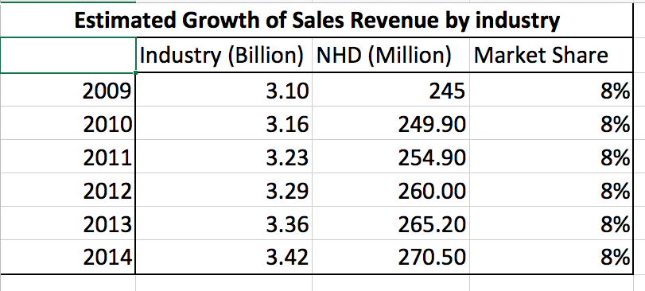
Divisions and consolidation
There are currently three operating divisions in the NHD - Production, Retail and Licensing. The Production division design and assembled dolls, accessories and other finished products for shipment. It generated $125 million in revenue which is about 37% of the total revenue before consolidation as 75% of it was internal sales to the retail division and only 25% is credited to the net sales after company consolidation. Doll accessories made up 15% of the total revenue. A large portion of the assembly and packaging was done overseas by third-party vendors.
Retail is the second division managing the sale of products manufactured by the Production division. Its merchandise is through three channels: a website (42%), a mail-order paper catalog (33%) and a network of retail stores (25%). It generated $190 million for 2009 which is about 56% of the total revenue before consolidation. Its 32 retail stores contribute annual revenue of $1.5 million each in US and Canada but it did not yet have a major presence in the Northeast.
The third division is media licensing division which generated annual revenue of $24.5 million with $14.5 million in operating profit. The media licensing strategy reduced the ongoing advertising and marketing spend and generally made the dolls more popular among customers.
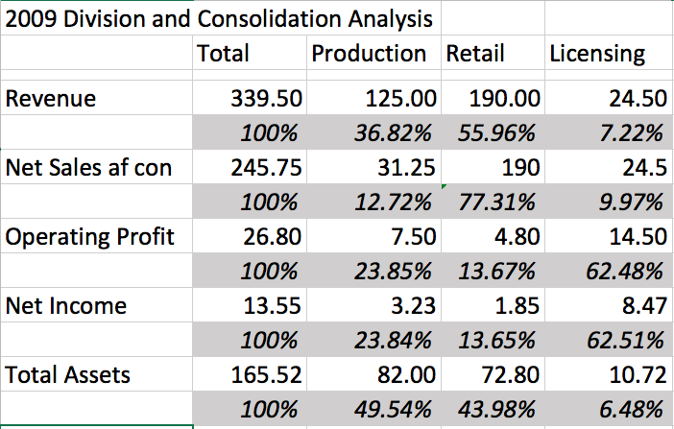
According to the chart above, it is obvious that licensing division contributes the most profit which is about 62.5% of the company total but with only 6.5% investment in assets. Production is the base of the company which occupies 50% of the assets and contribution about 24% for the profit. Since the company’s overriding strategic goal was to build and grow customer identification with its doll characters in various forms of product and entertainment through all stages of a child’s life, from toddlerhood through the teenage years. To leverage between the three divisions would be the biggest management and strategic challenge for the company management. Thus, the recommended strategy would be engaging all three division at every year for at least one new project.
The cost of capital
The company shall take the cost of capital into consideration for making decisions. Some factors such as the interest rates, credit crises, the market risk premium and tax rate that are not controllable by the company. While the company can still affect the cost of capital through its capital structure policy, dividend policy and investment policy. The optimal capital structure is the one that minimizes the weighted average cost of capital (WACC), which maximizes the intrinsic value of the stock. When the WACC reflects the average risk and overall capital structure of the entire company, no adjustments are needed using the WACC as the discount rate when estimating the value of a company by discounting its cash flows. However, the risk could be different if there are multiple divisions and for specific projects for the same division within the company. It is intuitively clear that riskier projects have a higher cost of capital but difficult to measure projects’ relative risks.
Three aspects need to be taken into consideration when making the evaluation. The stand-alone risk, the corporate risk and market risk. The company usually determine the divisional cost of capital first and then developing the risk-adjusted costs of capital for each category. They establish three risk classes – high, middle and low.
In the simulation, this is exact what NHD did. Please refer to the below adjusted discount rate matrix that we shall use for evaluating the project by its key financial performance date and indicators. The retail division is defined as the highest risk category and then production as a bit risky and licensing is the lowest. These rates are reasonably consistent with the profit and cost analysis made above across the divisions.
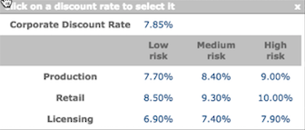
Projects and strategy
In the simulation, the CEO and the head of New Heritage's capital committee shall decide which projects the company's managers propose can be funded. The Board of Directors sets an annual limit of $7 million for capital projects starting from the first fiscal year. It is therefore necessary for the capital committee to select the best set of investments from the pool of available investment options in any given fiscal year. The selected investments will be monitored over a period of 5 years, from 2010 to 2014 for carrying out the above suggested strategy. Basically, the projects will be rated according to its NPV, IRR, PI and etc. as listed below. If the projects’ investment amount is within the budget limit, those projects will be all be selected independently. Some projects even if has good financial performance will not be selected due to the said investment limit and treated as exclusive projects.
2010 Projects
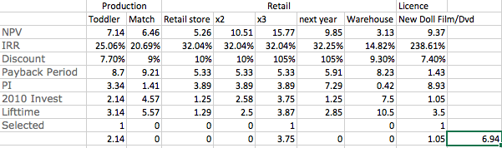
5 projects were provided for the first year.
The first selected “The New Doll Film/DVD” ranking the top as per the financial return among the options, is also consistent with the overall strategy to support the growth of licensing division. And then we need to decide between the two new lines for Production division. Toddler Doll Accessory Line provides higher NPV, IRR and PI with low risks, discount rate, less investment amount required and shorter payback period comparing with “Match my Doll” Clothing Line, is obviously a better choice if they are exclusive. The Retail division, it provides the opportunity to expansion the store into Northeast which is in line with the growth strategy which definitely beats the warehouse project. It also comes to the attention that the retail stores could be invested more than one and the NPV will be increased accordingly. Three stores were invested eventually to add up the total investment to 6.94 million.
The result turned out to be better than expected with the 2010 company APV of 329.84 and revenue increased slightly to $252.42 million ($245.75 2009).
2011 Projects
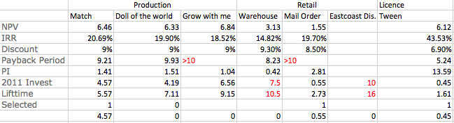
7 projects were provided for the 2nd year.
To leverage between the division, we still need to assign at least 1 new project to each. “Tween Book Series” for Licensing looks good as per NPV, IRR and PI and low risk and investment and it was reported a boosted revenue growth above expectation. Due to the capital limit, the retail project “Expansion of Mail Order Catalog business to Asia” is selected even though the payback period is longer than 10 years but the estimated return is relatively good with only $0.55 million investment. It supports well with the strategy for expansion into Asia market in a long run and the catalog still contributes 33% for the retail revenue. It is said that the concept testing is expensive but the revenues were likewise much higher than expected.
The most difficult decision needs to be made for Production division among “Match my Doll” Clothing Line, “Dolls of the world” and “Grow with me”. Due to the limit of capital, “Grow with me” is wiped out for the payback period more than 10 years. And “Match my Doll” was selected for its connection with “Tween” and relatively higher return and less payback period. The financial result is satisfactory.
The company APV was increased by 14% and consolidated net sales revenue was by 15% comparing with last year.

2012 Projects
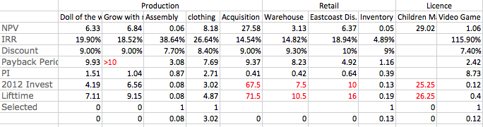
10 projects were provided for the 3rd year.
For the licensing division, the only option is Doll Video Game as the acquisition of Children’s Magazine needs huge investment in amount and time. While for retail that both the “Warehouse” and “East coast Distribution” exceeds the investment limit and “New Inventory control system” seems to be important for future production line expansion and savings of operations in a long run. The “Acquisition” and “Grow with me” were not accepted because of the huge investment in amount and time. The “Clothing line” is a continuous expansion from last year with good NPV and IRR. “Doll of the world” could be an option if the investment amount did not exceed the limit. Unfortunately, we need to leverage between the divisions and “Assembly” was selected as a substitute.
Thus, the consolidated sales revenue was still added up by 14% but the company APV was only 5% increased due to the insufficient use of all the investment fund.
2013 Projects
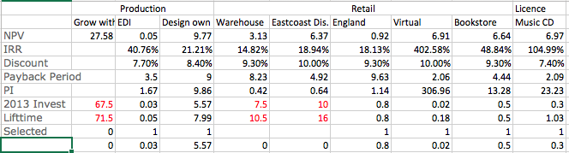
9 projects were provided for the 4th year.
For the licensing division, the only option is Toddlers Music CD Series. It is no doubt to be selected as per its good performance. The “Design your own Doll” appears to be positive under the Production division with high return of investment and relatively normal payback period and lifetime. Due to the development of the technology, the EDI Supplier Software is worth consideration due to its low risk and high IRR. All the options proposed by Retail, except those exceeding the capital limit and low PI, are selected due to its low capital requirement but high IRR. The Expansion to England is part of the global expansion strategy. The trial of this project could provide experience and lessons to company for future growth. In addition, the “Virtual Doll Community” and “Bookstore Café and Writers’ Club helps in promotion of the sales and increase the customer’s loyalty. Especially, the “Virtual” requires very small investment as of $0.02 million but very high return with only 2 years payback period. This reflects the business trend combining with technology.
Because of the delay of “Design Your Own Doll” production, the net sales increased a bit slow i.e. 6% comparing with yearly average. But the company APV was increased constantly up to 450 by 14%.
2014 Projects
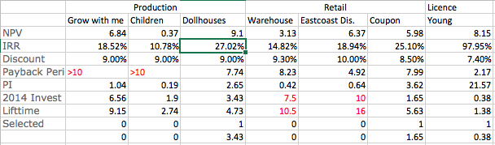
In the last year for the simulation, there are 5 projects to be reviewed.
For the Licensing division, the only option is the “Young authors Book Series” which provides strong NPV, IRR with low risk and investment requirement. Due to the constraint of the investment fund, the options of “East Cost Distribution Channels” and “Warehouse” still could not be considered. Thus the “Coupon Promotion” would be the only one left for the retail division. The remaining fund was considered to be invested in the “Dollhouses” project proposed by Production division as it shows the best return under the same discount rate.
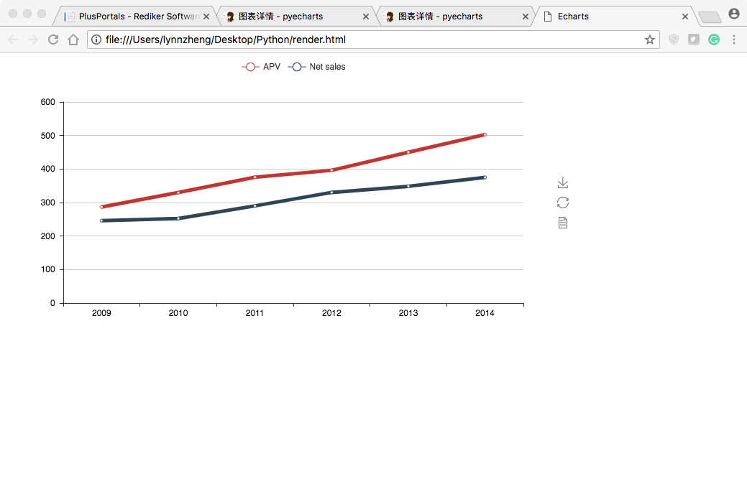
By the end this year, the company APV reached to 502.71 which is about 12% increase and consolidated sales revenue up to $374.85 million by a moderate increase of 8%. The main reason for relatively slow growth result is much related to the unavailability of good projects proposed by the divisions.
Conclusion and outlook
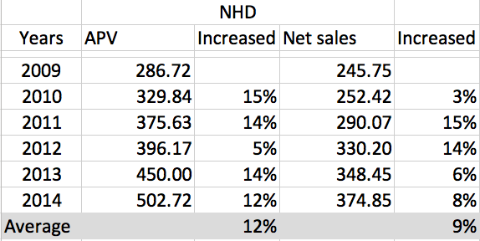
In order to maximize the use of available capital within the said 5 years and balance between the divisions. Any projects that fall in the below categories are not selected in the simulation.
- needs investment in a long term i.e. more than 10 years; or
- the investment amount exceeds the internally provided capital limit; or
- related to acquisition or very large investments to be funded rather than the internal resources.
But some of the long-term investment such as the good quality acquisitions and very large investments opportunity shall be taken into consideration and could be funded by the acquisition of additional debt and investments were not funded by the general capital investment pool. There is no best choice if you only read from the financial figures but the most optimized strategy shall be risk-resistant and flexible for periodic adjustment when necessary to interact with both internal and external opportunity and threats.

